**Python Environment:**

* Install Python
* Create Python environment using requirement.txt

**Load custom data and its annotation file to create Custom Dataset:**

**Load Annotation File**

import json

import cv2

import numpy as np

from tensorflow.keras.utils import to_categorical

# Load the JSON file

with open('Bird/annotations/train_annotations.json', 'r') as f:

    annotations = json.load(f)

**Create Dataset:**

def load_dataset(annotations, image_dir, input_shape=(224, 224), num_classes=3):

    images = []

    bboxes = []

    labels = []

    for annotation in annotations['annotations']:

        image_id = annotation['image_id']

        bbox = annotation['bbox']  # [x, y, width, height]

        category_id = annotation['category_id']

        # Load the image

        image_info = next(item for item in annotations['images'] if item['id'] == image_id)

        image_path = f"{image_dir}/{image_info['file_name']}"

        image = cv2.imread(image_path)

        image = cv2.resize(image, input_shape[:2])

        # Normalize the bounding box

        x_min, y_min, width, height = bbox

        x_max = x_min + width

        y_max = y_min + height

        x_min /= image_info['width']

        y_min /= image_info['height']

        x_max /= image_info['width']

        y_max /= image_info['height']

        # Append the data

        images.append(image)

        bboxes.append([x_min, y_min, x_max, y_max])

        labels.append(category_id)

    images = np.array(images)

    bboxes = np.array(bboxes)

    labels = to_categorical(labels, num_classes=num_classes)

    return images, bboxes, labels

# Specify the directory where images are stored

image_dir = r'Bird/images/train'

# Load the dataset

X, y_bboxes, y_labels = load_dataset(annotations, image_dir, input_shape=(224, 224), num_classes=3)

**Split dataset in training and validation:**

from sklearn.model_selection import train_test_split

X_train, X_val, y_bboxes_train, y_bboxes_val, y_labels_train, y_labels_val = train_test_split(

    X, y_bboxes, y_labels, test_size=0.2, random_state=42)

**Visualize the dataset**

import matplotlib.pyplot as plt

# Class names (replace these with your actual class names)

class_names = {0: 'SuperBird', 1: 'Bird', 2: 'Background'}

def visualize_dataset(images, bboxes, labels, num_images=2):

    for i in range(num_images):

        image = images[i]

        bbox = bboxes[i]

        label = labels[i]

        # Denormalize bounding box

        h, w, _ = image.shape

        x_min, y_min, x_max, y_max = bbox

        x_min = int(x_min * w)

        y_min = int(y_min * h)

        x_max = int(x_max * w)

        y_max = int(y_max * h)

        # Plot the image

        plt.figure(figsize=(8, 8))

        plt.imshow(cv2.cvtColor(image, cv2.COLOR_BGR2RGB))

        # Plot the bounding box

        plt.gca().add_patch(plt.Rectangle((x_min, y_min), x_max - x_min, y_max - y_min, edgecolor='red', facecolor='none', linewidth=2))

        # Plot the label

        label_idx = np.argmax(label)  # Get the index of the class

        class_name = class_names[label_idx]

        plt.text(x_min, y_min - 10, class_name, color='red', fontsize=12, weight='bold')

        plt.axis('off')

        plt.show()

# Visualize 5 images

visualize_dataset(X, y_bboxes, y_labels, num_images=5)

**First two images from Dataset and their bounding box:**

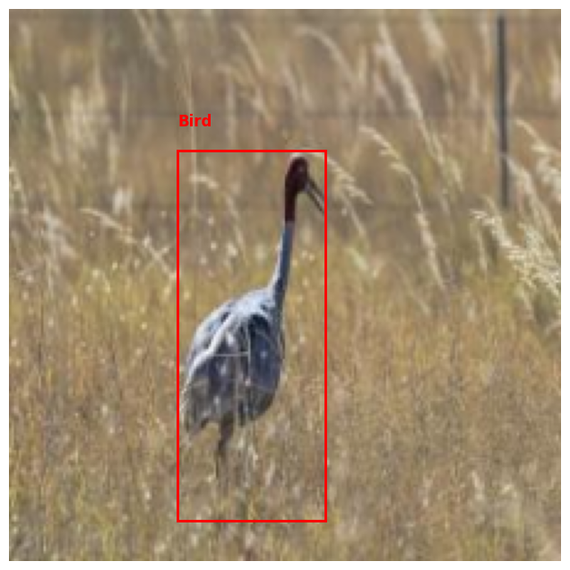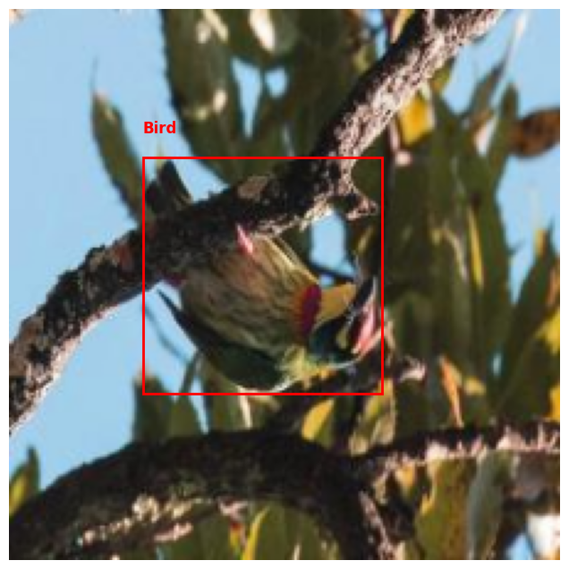

**Create Model:**

**Define function to create model:**

import tensorflow as tf

from tensorflow.keras import layers, models, Input

def create_model(input_shape=(224, 224, 3), num_classes=3):

    inputs = Input(shape=input_shape)

    # Convolutional layers

    x = layers.Conv2D(32, (3, 3), activation='relu')(inputs)

    x = layers.MaxPooling2D((2, 2))(x)

    x = layers.Conv2D(64, (3, 3), activation='relu')(x)

    x = layers.MaxPooling2D((2, 2))(x)

    x = layers.Conv2D(128, (3, 3), activation='relu')(x)

    x = layers.MaxPooling2D((2, 2))(x)

    x = layers.Conv2D(256, (3, 3), activation='relu')(x)

    x = layers.MaxPooling2D((2, 2))(x)

    x = layers.Flatten()(x)

    x = layers.Dense(512, activation='relu')(x)

    # Output layers

    bbox_output = layers.Dense(4, activation='sigmoid', name='bbox_output')(x)

    class_output = layers.Dense(num_classes, activation='softmax', name='class_output')(x)

    # Model

    model = models.Model(inputs=inputs, outputs=[bbox_output, class_output])

    return model

**Create callbacks to monitor the progress**

from tensorflow.keras.callbacks import TensorBoard

# Define TensorBoard callback

tensorboard_callback = TensorBoard(log_dir='./logs', histogram_freq=1)

**Create Model**

model = create_model(input_shape=(224, 224, 3), num_classes=3)

model.compile(optimizer='adam',

              loss={'bbox_output': 'mean_squared_error', 'class_output': 'categorical_crossentropy'},

              metrics={'bbox_output': 'mse', 'class_output': 'accuracy'})

**Train the model**

# Assuming X_train is your input images, y_bbox_train is the bounding box labels, and y_class_train is the class labels

history = model.fit(X_train,

                    {'bbox_output': y_bboxes_train, 'class_output': y_labels_train},

                    epochs=20,

                    batch_size=32,

                    validation_data=(X_val, {'bbox_output': y_bboxes_val, 'class_output': y_labels_val})

                    callbacks=[tensorboard_callback])

**Plot the Metrics**:

import matplotlib.pyplot as plt

def plot_metrics(history):

    # Plot bounding box loss

    plt.figure(figsize=(12, 6))

    plt.plot(history.history['bbox_output_loss'], label='Bounding Box Loss (Train)')

    plt.plot(history.history['val_bbox_output_loss'], label='Bounding Box Loss (Val)')

    plt.title('Bounding Box Loss')

    plt.xlabel('Epoch')

    plt.ylabel('Loss')

    plt.legend()

    plt.grid()

    plt.show()

    # Plot class accuracy

    plt.figure(figsize=(12, 6))

    plt.plot(history.history['class_output_accuracy'], label='Class Accuracy (Train)')

    plt.plot(history.history['val_class_output_accuracy'], label='Class Accuracy (Val)')

    plt.title('Class Accuracy')

    plt.xlabel('Epoch')

    plt.ylabel('Accuracy')

    plt.legend()

    plt.grid()

    plt.show()

# Plot the metrics

plot_metrics(history)

**Metrics result:**

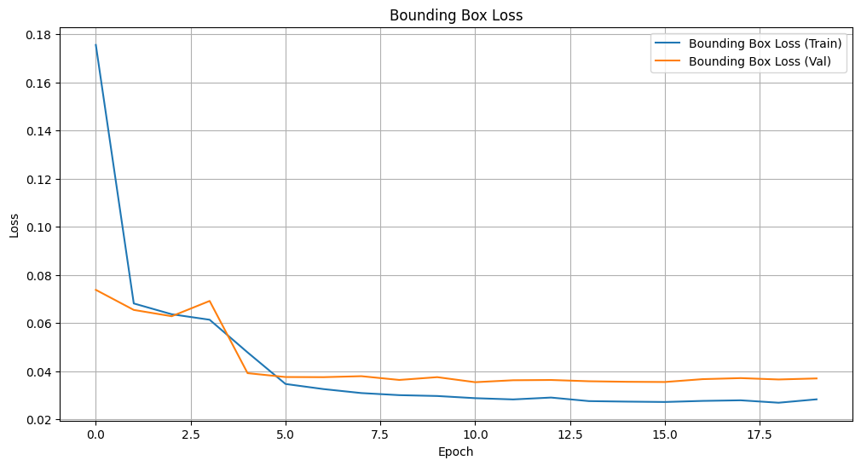

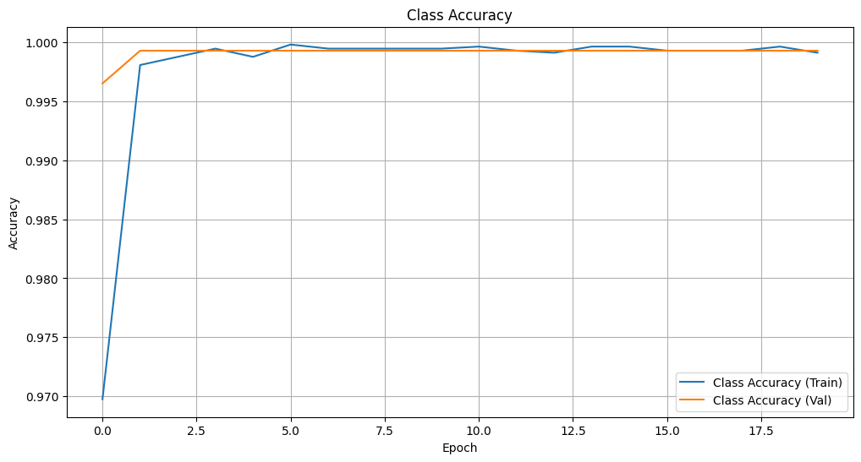

**Save the model to .h5 format:**

# Save the entire model to a file

model.save('Bird/trained_models/newModel/my_model.h5')

**Creation of TFLite Model:**

**Load Model**

from tensorflow.keras.models import load_model

# Load the previously saved model

loaded_model = load_model('Bird/trained_models/newModel/my_model.h5')

**Convert and save to TFLite format**

import tensorflow as tf

# Convert the model to TFLite format

converter = tf.lite.TFLiteConverter.from_keras_model(loaded_model)

converter.optimizations = [tf.lite.Optimize.DEFAULT]

tflite_model = converter.convert()

# Save the TFLite model to a file

with open('Bird/trained_models/newModel/my_model.tflite', 'wb') as f:

    f.write(tflite_model)